A3 Problem Solving for Bright Ideas

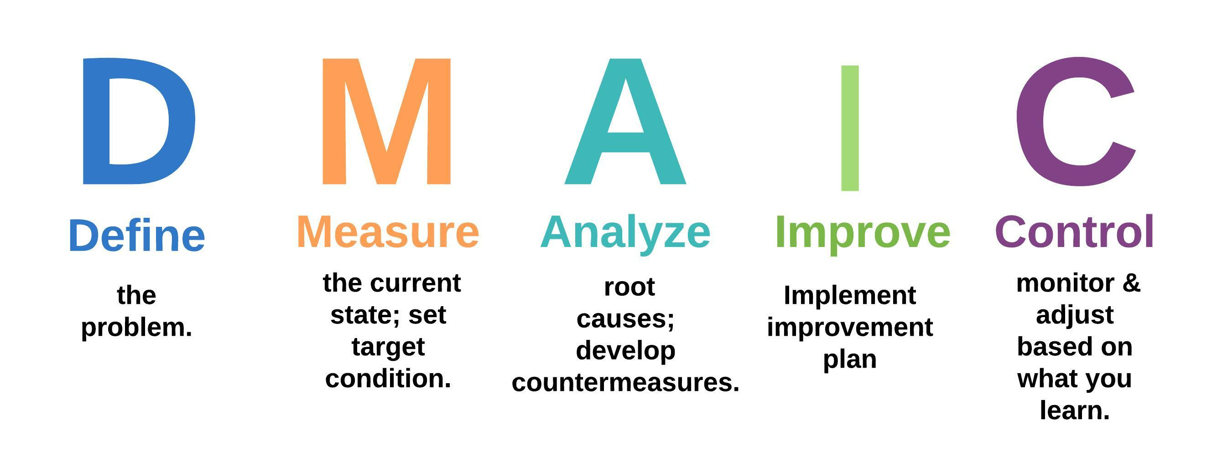

- Define
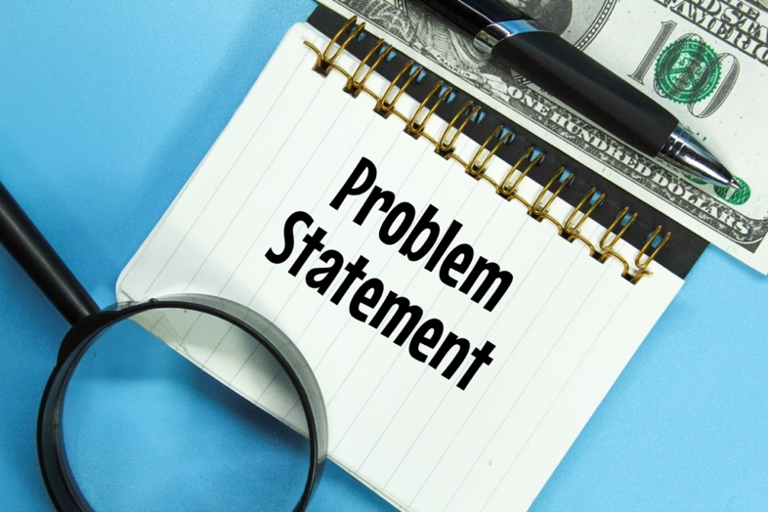

  - What’s the problem you want to address?
  - Does this problem impact any key result areas? (Safety, quality, cost, delivery, or morale?) If so, to what extent?
  - Why is it important to address this problem? (Scope? Impact? Trend? Urgency?)

- Measure

  - Go to the Gemba to investigate the problem. (Use Gemba observation worksheet)
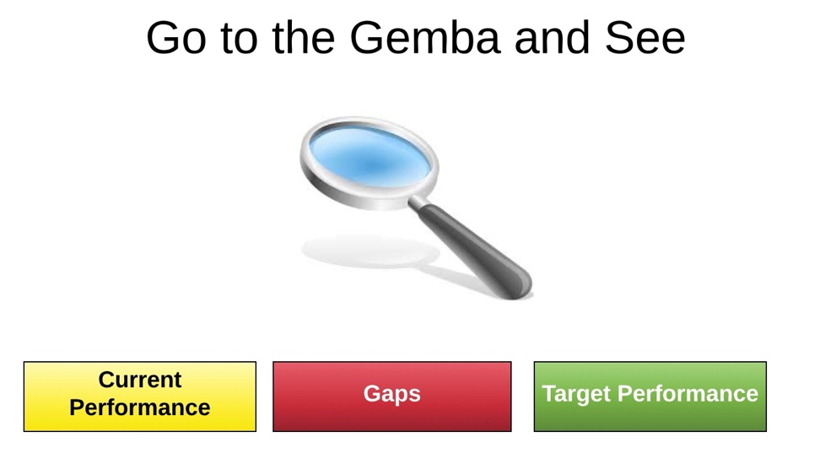
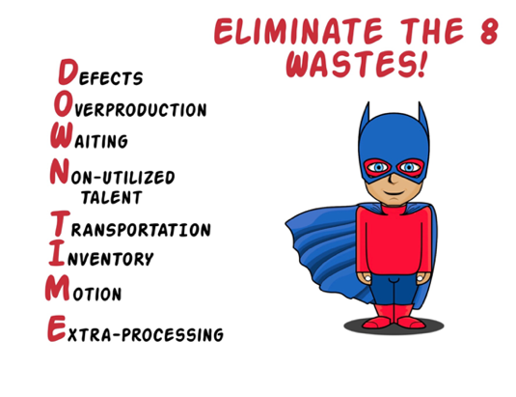
  - Did you discover any examples of the 8 wastes? If so, which ones?
  - Visually show evidence of the problem with charts, diagrams, graphs, pictures, drawings, etc.
  - Did your initial perception of the problem change after observing it at the Gemba? Why or why not?
  - What are your specific improvement goals?
Key Result Area | Current Condition | Target Condition | By When?

- Analyze
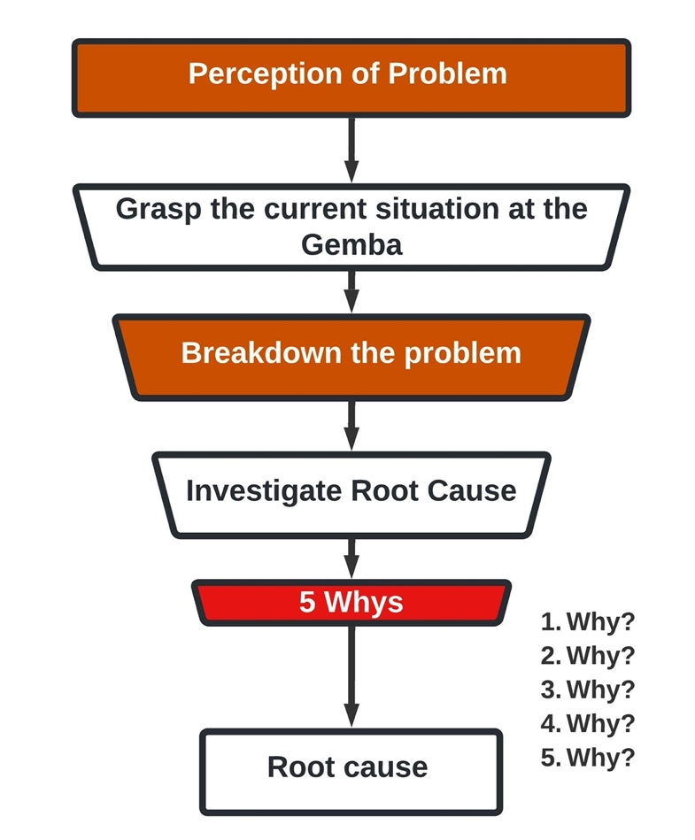
  - Brainstorm contributory causes of the problem and organize them into applicable categories on a fishbone diagram.
  - Use 5 Whys to dive deeper and discover the problem’s root causes.
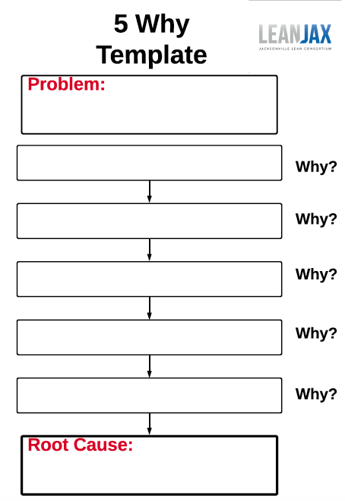
  - List the identified root causes.
  - What ideas do you have to address these root causes?
- Can you apply mistake proofing, visual management, 6S workplace organization, standard work, training?
  - Prioritize your improvement ideas and select the ones you want to try.

- Improve
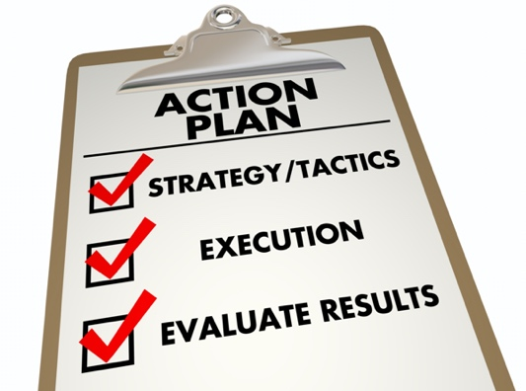

  - Create an improvement plan from your selected ideas.
- What are the action items?
- What is the best sequence?
- Who is responsible for each action item?
- What resources/ support do you need?
- When is each action item due?
- What is the status of each action item?
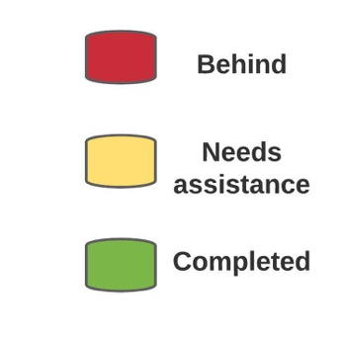
Action item | Owner | Supporters | Target Date | Status

- Control
  - When will you know if your improvement plan was successful?
  - When will you review the status of your improvement plan? Who will you review it with.
Review Date | Attendees

  - After reviewing the status, do you need to adjust your improvement plan based on what you learned?
  - Did you achieve your improvement goals? Why or why not?
  - Visually depict improvement plan results with charts, graphs, pictures, drawings, etc.
  - What did you learn? Would you do anything different next time?
  - Celebrate success!
  - What’s next?

